lu decomposition

FUNCTION : LU Decomposition

Purpose: This function decomposes a square matrix A into a lower triangular matrix (L) and an upper triangular matrix (U) such that A = LU.

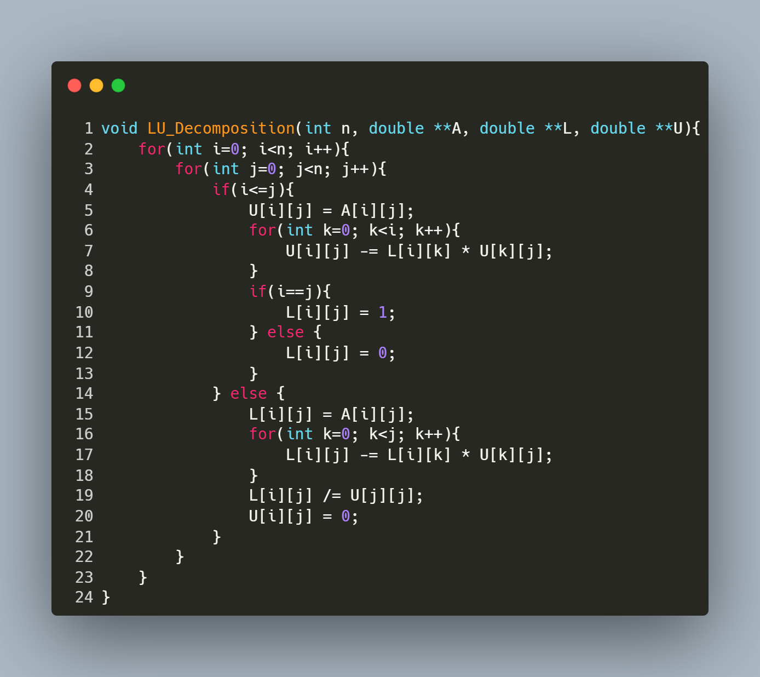
Step-by-Step Explanation
1. Matrix Traversal
- The outer loops iterate over each element of the matrix:
  - i represents the current row.
  - j represents the current column.
2. Upper Triangular Matrix (U)
For elements where i ≤ j (diagonal and upper triangle):
- Initialize U[i][j]:

U[i][j] = A[i][j];
- Subtract Contributions from Previous Rows:
for (int k = 0; k < i; k++) {
U[i][j] -= L[i][k] * U[k][j];
}
This eliminates dependencies on earlier rows using the formula:
- U[i][j]=A[i][j]−$\sum_{k=0}^{i-1}{L\left[i\right]\left[k\right]*U[k][j]}$
- Set L[i][j]:
  - Diagonal (i == j): L[i][j] = 1.0 (unit lower triangular matrix).
  - Upper triangle (i < j): L[i][j] = 0.0.
3. Lower Triangular Matrix (L)
For elements where i > j (lower triangle):
- Initialize L[i][j]:
L[i][j] = A[i][j];
- Subtract Contributions from Previous Columns:
for (int k = 0; k < j; k++) {
L[i][j] -= L[i][k] * U[k][j];
}
This uses the formula:
- L[i][j]=$\frac{A\left[i\right]\left[j\right]- \sum_{k=0}^{i-1}{L\left[i\right]\left[k\right]*U[k][j]}}{U\left[j\right][j]}$
- Normalize by U[j][j]:
L[i][j] /= U[j][j];
- Set U[i][j]:
c
U[i][j] = 0.0; // Ensure upper triangle elements below diagonal are zero

function: Forward Substitution

Purpose: This function solves a system Lx = b where L is a lower triangular matrix
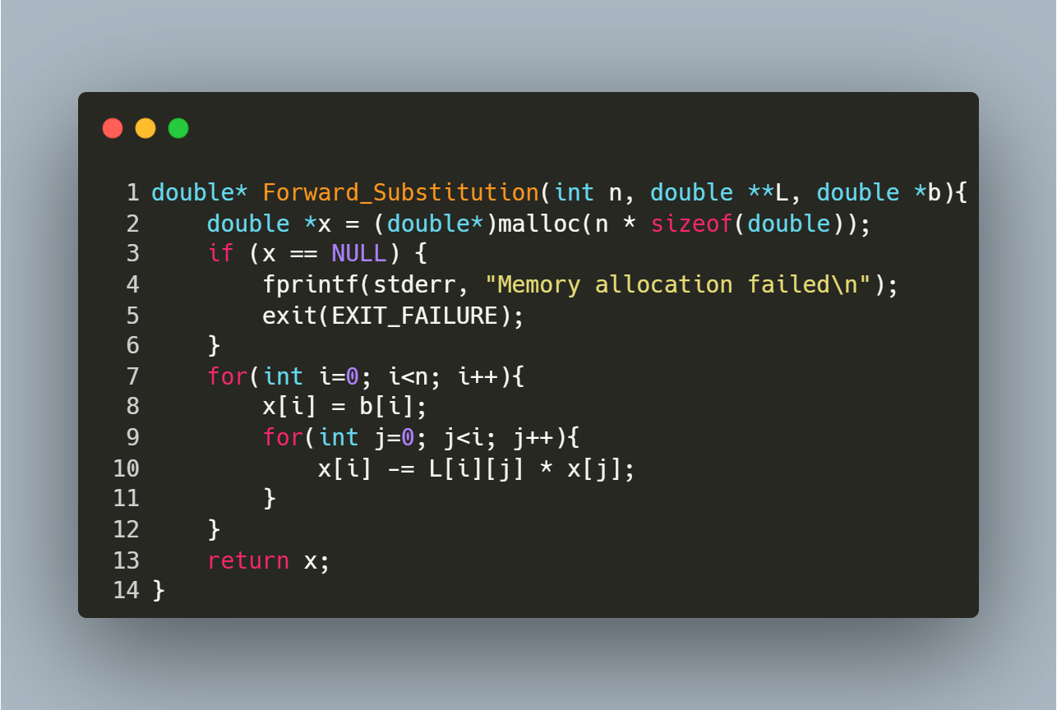
Step-by-Step Explanation
- Memory Allocation:
  - Allocates memory for the solution vector x.
  - Exits with an error if allocation fails.
- Forward Substitution Loop:
  - Iterates over each row i from 0 to n-1:
    - Initialize: x[i] = b[i] (start with the right-hand side value).
    - Subtract Known Terms: For each column j < i, subtract L[i][j] * x[j] to eliminate dependencies on previously computed x[j].
  - No Division Needed: L is a unit lower triangular matrix (1s on the diagonal), so no division by L[i][i] is required.

function: Backward Substitution

Purpose: This function solves a system Ux = b where U is an upper triangular matrix.
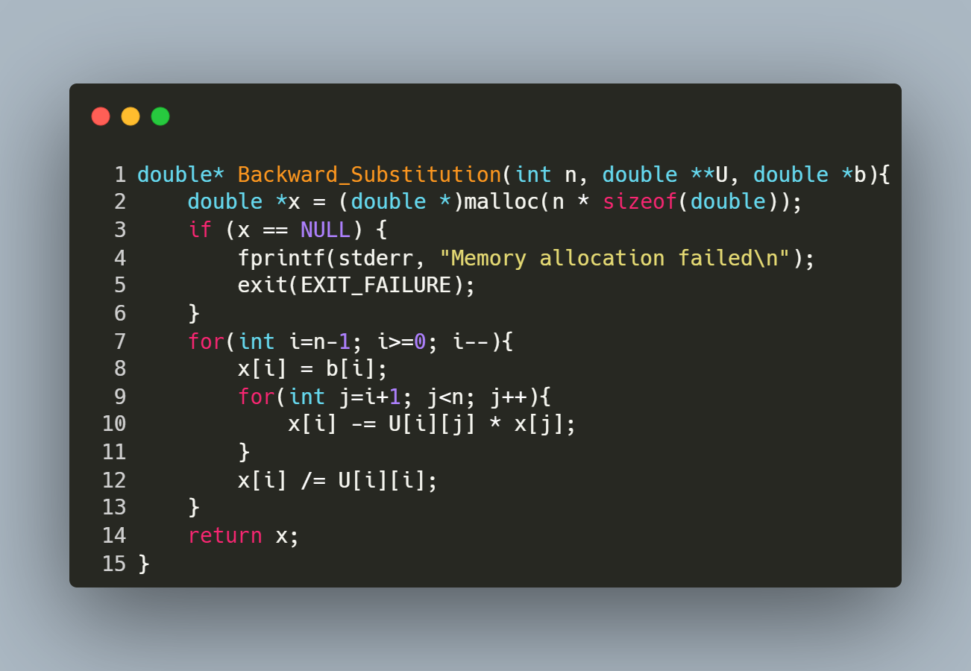
Step-by-Step Explanation
- Memory Allocation:
  - Allocates memory for the solution vector x.
  - Exits with an error if allocation fails.
- Backward Substitution Loop:
  - Iterates over rows i from bottom to top (n-1 to 0):
    - Initialize: x[i] = b[i] (start with the right-hand side value).
    - Subtract Known Terms: For each column j > i, subtract U[i][j] * x[j] to eliminate dependencies on already computed x[j].
    - Normalize: Divide by U[i][i] to isolate x[i].

function : Reading Matrix and Vector Input from a File

Purpose: This function reads a square matrix A of size n x n and a vector b of size n from a file named "inputs.txt". It ensures proper error handling for file operations and input parsing.
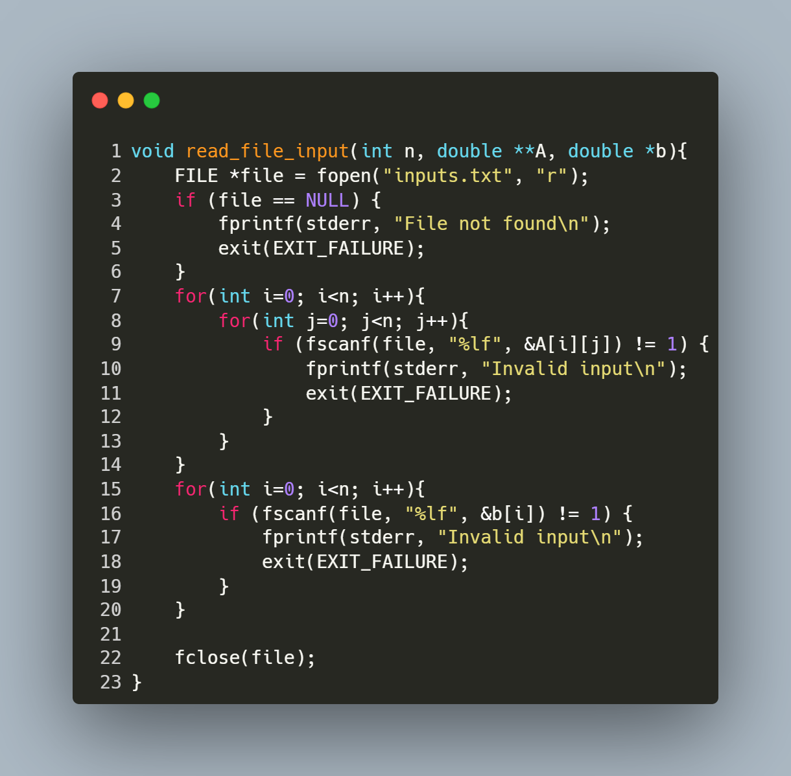
Step-by-Step Explanation
- Open File:
  - FILE *file = fopen("inputs.txt", "r"); opens the file "inputs.txt" in read mode.
  - If the file cannot be opened (e.g., it doesn't exist), the program prints an error message ("File not found") and exits.
- Read Matrix Elements:
  - The nested loop for (int i = 0; i < n; i++) { for (int j = 0; j < n; j++) { ... } } iterates through each row (i) and column (j) of matrix A.
  - fscanf(file, "%lf", &A[i][j]) reads a floating-point number from the file and stores it in the corresponding position in A.
  - If the input is invalid or missing, the program prints "Invalid input" and exits.
- Read Vector Elements:
  - The loop for (int i = 0; i < n; i++) { ... } iterates through each element of vector b.
  - fscanf(file, "%lf", &b[i]) reads a floating-point number from the file and stores it in the corresponding position in b.
  - Similar error handling ensures that invalid or missing input causes the program to terminate with an error message.
- Close File:
fclose(file); closes the file after all data has been read to release system resources.

Main Program for Solving Linear Systems via LU Decomposition

Purpose: This program solves a linear system Ax = b using LU decomposition. It reads matrix A and vector b from a file, factors A into lower triangular matrix L and upper triangular matrix U, solves for x using forward/backward substitution, and reports timings and results.
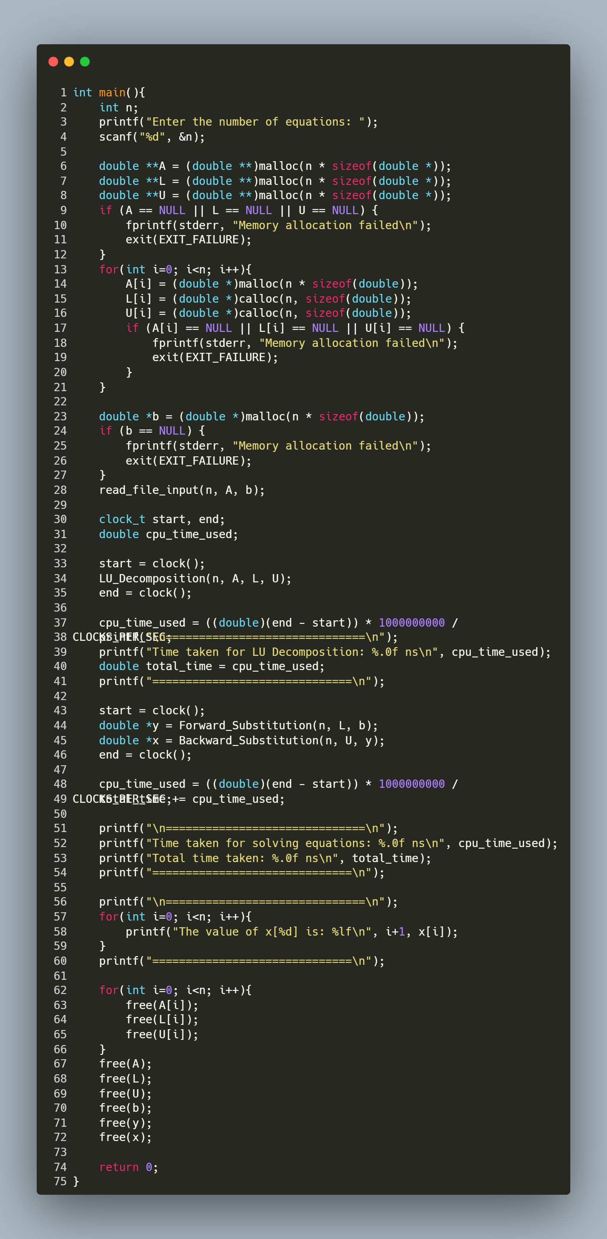
Step-by-Step Explanation
1. User Input & Memory Allocation
- Prompts the user for the number of equations (n).
- Allocates memory for:
  - A (n x n matrix).
  - L (unit lower triangular matrix, initialized with calloc).
  - U (upper triangular matrix, initialized with calloc).
  - b (vector of size n).
- Includes error handling for memory allocation failures.
2. Read Input File
- Calls read_file_input(n, A, b) to load A and b from "inputs.txt".
3. LU Decomposition & Timing
- LU_Decomposition(n, A, L, U) factors A into L and U.
- Measures and prints the time taken for decomposition in nanoseconds.
4. Solve Linear System
- Forward Substitution: Solves Ly = b to get intermediate vector y.
- Backward Substitution: Solves Ux = y to get the solution vector x.
- Measures and prints the time taken for solving the system.
5. Print Results
- Displays the solution vector x with 6 decimal places.
6. Memory Cleanup
- Frees all dynamically allocated memory for A, L, U, b, y, and x.
Key Notes
- Timing:
  - Uses clock() to measure CPU time.
  - Converts time to nanoseconds for readability.
  - WSL vs. Terminal: Timing accuracy may vary between environments.

